**Batch: C2-1 Roll No.: 16010122104**

**Experiment / assignment / tutorial No. 1**

**Grade: AA / AB / BB / BC / CC / CD /DD**

**Signature of the Staff In-charge with date**

|  |
| --- |
| **TITLE:** Write a program for:  a. Program to find area and circumference of various Geometric shapes.  b. Program to calculate EMI (Equated Monthly Instalment) of loan amount if principal, rate of interest and time in years is given by the user.  (E = (P.r.(1+r)n) / ((1+r)n – 1) |

**AIM:** Write a program for:

a. Program to find area and circumference of various Geometric shapes.

b. Program to calculate EMI (Equated Monthly Instalment) of loan amount if principal, rate of interest and time in years is given by the user.

E = (P.r.(1+r)n) / ((1+r)n – 1)

**____________________________________________________________**

**Expected OUTCOME of Experiment:**

1. To run a program successfully and find the area and circumference of the given shape.
2. To run a program successfully and calculate EMI (Equated Monthly Instalment) of loan amount if principal, rate of interest and time in years is given by the user.

**_____________________________________________________________________**

**Books/ Journals/ Websites referred:**

1. Programming in ANSI C, E. Balagurusamy, 7 th Edition, 2016, McGraw-Hill Education, India.
2. Structured Programming Approach, Pradeep Dey and Manas Ghosh, 1 st Edition, 2016, Oxford University Press, India.
3. Let Us C, Yashwant Kanetkar, 15th Edition, 2016, BPB Publications, India.

**_____________________________________________________________________**

**Problem Definition:**

Problem 1 : Area and Circumference of any shape(**will be given by instructor**) (example Circle)

Ask the user to enter the value of the radius of a circle.  Put the values in the formula for finding area of a circle and circumference of a circle and print the outcome for area of a circle and circumference of a circle

#include <stdio.h>

void main()

{

//circle

const int pi=3.14;

float r, a1=0.0, cir=0.0;

printf("Enter radius of Circle: ");

scanf("%f", &r);

cir=2*pi*r;

a1=pi*r*r;

printf("\nArea of the Circle= %0.2f", a1);

printf("\nCircumference of Circle= %0.2f", cir);

getch();

}

Problem 2: Calculating EMI

Ask the user to enter the value of principal amount, rate of interest and time (in years).Store the value in E and print the final monthly instalment E as an outcome.

Formula to be used: (E = (P.r.(1+r)n) / ((1+r)n – 1)

#include<stdio.h>

void main()

{

//emi

float p, r, t, e=0.0;

printf("Enter your principle amount: ");

scanf("%f",&p);

printf("Enter your rate of EMI: ");

scanf("%f",&r);

printf("Enter your time period: ");

scanf("%f",&t);

r=r/1200.0;

t=t*12;

e=(p*r*pow(1+r,t))/(pow(1+r,t)-1);

printf("Your EMI is Rs. %f", e);

}

**Flowchart:**

1. Shape

   Description automatically generatedDiagram

   Description automatically generated b.

**Implementation details:**

a.

1. Start
2. Declare constant pi for 3.14 and variables r for radius, a1 for area and cir for circumference
3. Accept radius from user
4. cir=2*pi*r
5. a1=pi*r*r
6. Display area and circumference
7. Stop

b.

1. Start
2. Declare variables p for principle value, r for rate of interest, t for time period and e for emi
3. Accept p, r, t from user
4. r=r/1200.0
5. t=t*12
6. e=(p*r*pow(1+r,t))/(pow(1+r,t)-1)
7. Display emi
8. Stop

**Output(s):**

**a.**

b.

**Conclusion:**

We learned the basics for declaring a variable, accepting a variable from user and computing basic equations

**Post Lab Descriptive Questions**

1. **What are the basic data types in C?**

**Ans: primitive, user defined, void and derived.**

1. **What is a flowchart? What are the standard symbols used to draw a flowchart ? Explain in brief.**

**Ans: Flowchart is a graphical representation of an algorithm. Programmers often use it as a program-planning tool to solve a problem. It makes use of symbols which are connected among them to indicate the flow of information and processing.   
The process of drawing a flowchart for an algorithm is known as “flowcharting”.**

**Basic Symbols used in Flowchart Designs**

1. **Terminal: The oval symbol indicates Start, Stop and Halt in a program’s logic flow. A pause/halt is generally used in a program logic under some error conditions. Terminal is the first and last symbols in the flowchart.**

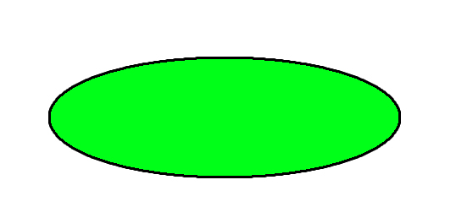

* **Input/Output: A parallelogram denotes any function of input/output type. Program instructions that take input from input devices and display output on output devices are indicated with parallelogram in a flowchart.**

* **Processing: A box represents arithmetic instructions. All arithmetic processes such as adding, subtracting, multiplication and division are indicated by action or process symbol.**

* **Decision Diamond symbol represents a decision point. Decision based operations such as yes/no question or true/false are indicated by diamond in flowchart.**

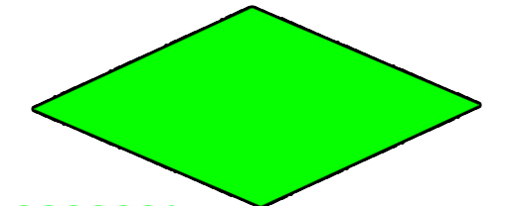

* **Connectors: Whenever flowchart becomes complex or it spreads over more than one page, it is useful to use connectors to avoid any confusions. It is represented by a circle.**

* **Flow lines: Flow lines indicate the exact sequence in which instructions are executed. Arrows represent the direction of flow of control and relationship among different symbols of flowchart.**

**Date: 07/01/2023 Signature of faculty in-charge**